*ADITHYA DUTT KAMBHAMPATI*

*RA2011003011072*

**QUANTUM COMPUTATION CT 3 LAB ASSIGNMENT**

1. **Demonstrate Deutsch Algorithm for oracular function $f\left(0\right)=1 \& f\left(1\right)=0$.**

Code:

import numpy as np

# Importing standard Qiskit libraries

from qiskit import QuantumCircuit, transpile, Aer, IBMQ, QuantumRegister, ClassicalRegister, execute, BasicAer

from qiskit.tools.jupyter import *

from qiskit.visualization import *

from ibm_quantum_widgets import *

from qiskit.providers.aer import QasmSimulator

# Loading your IBM Quantum account(s)

provider = IBMQ.load_account()

backend = BasicAer.get_backend('qasm_simulator')

shots=1024

qreg1 = QuantumRegister(2) # The quantum register of the qubits, in this case 2 qubits

register1 = ClassicalRegister(1)

qc = QuantumCircuit(qreg1, register1)

qc.x(1)

qc.barrier()

qc.h([0,1])

qc.barrier()

qc.draw()

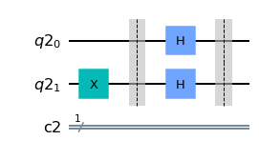

qc.cx(0,1)

qc.barrier()

qc.draw()

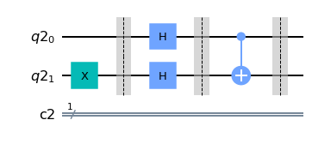

qc.h(0)

qc.draw()

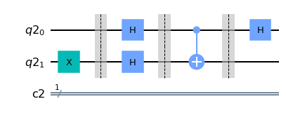

qc.measure(qreg1[0],register1)

qc.draw()

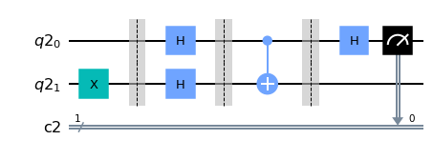

results = execute(qc, backend=backend, shots=shots).result()

answer = results.get_counts()

plot_histogram(answer)

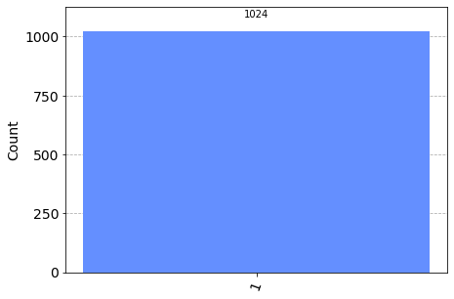

1. **Demonstrate Grover’s Algorithm for $w=01$ as the two-bit special string. Create the entire circuit and showcase how the circuit reveals the secret string hidden in the oracle.**

Code:

import numpy as np

# Importing standard Qiskit libraries

from qiskit import QuantumCircuit, transpile, Aer, IBMQ

from qiskit.tools.jupyter import *

from qiskit.visualization import *

from ibm_quantum_widgets import *

from qiskit.providers.aer import QasmSimulator

# Loading your IBM Quantum account(s)

provider = IBMQ.load_account()

#initialization

import matplotlib.pyplot as plt

import numpy as np

# importing Qiskit

from qiskit import IBMQ, Aer, assemble, transpile

from qiskit import QuantumCircuit, ClassicalRegister, QuantumRegister

from qiskit.providers.ibmq import least_busy

# import basic plot tools

from qiskit.visualization import plot_histogram

def initialize_s(qc, qubits):

"""Apply a H-gate to 'qubits' in qc"""

for q in qubits:

qc.h(q)

return qc

n = 2

grover_circuit = QuantumCircuit(n)

grover_circuit = initialize_s(grover_circuit, [0,1])

grover_circuit.draw()

grover_circuit.cz(0,1) # Oracle

grover_circuit.draw()

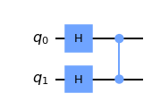

# Diffusion operator (U_s)

grover_circuit.h([0,1])

grover_circuit.x([1])

grover_circuit.cz(1,0)

grover_circuit.h([0,1])

grover_circuit.draw()

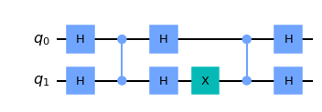

sim = Aer.get_backend('aer_simulator')

# we need to make a copy of the circuit with the 'save_statevector'

# instruction to run on the Aer simulator

grover_circuit_sim = grover_circuit.copy()

grover_circuit_sim.save_statevector()

qobj = assemble(grover_circuit_sim)

result = sim.run(qobj).result()

statevec = result.get_statevector()

from qiskit_textbook.tools import vector2latex

vector2latex(statevec, pretext="|\\psi\\rangle =")

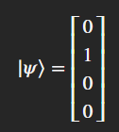

grover_circuit.measure_all()

aer_sim = Aer.get_backend('aer_simulator')

qobj = assemble(grover_circuit)

result = aer_sim.run(qobj).result()

counts = result.get_counts()

plot_histogram(counts)

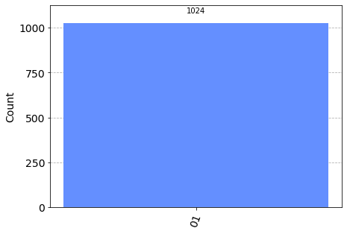

# Load IBM Q account and get the least busy backend device

provider = IBMQ.load_account()

provider = IBMQ.get_provider("ibm-q")

device = least_busy(provider.backends(filters=lambda x: int(x.configuration().n_qubits) >= 3 and

not x.configuration().simulator and x.status().operational==True))

print("Running on current least busy device: ", device)

# Run our circuit on the least busy backend. Monitor the execution of the job in the queue

from qiskit.tools.monitor import job_monitor

transpiled_grover_circuit = transpile(grover_circuit, device, optimization_level=3)

job = device.run(transpiled_grover_circuit)

job_monitor(job, interval=2)

# Get the results from the computation

results = job.result()

answer = results.get_counts(grover_circuit)

plot_histogram(answer)

